A

PROJECT REPORT

ON

**BOOK FOREVER**



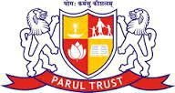

**SUBMITTED TO:**

PARUL POLYTECHNIC INSTITUTE (1ST SHIFT)

POST – LIMDA, WAGODIA – 39176